CUSTOM BOOTCAMP
Databricks

Delta Architecture with Medallion Data Quality Data Flow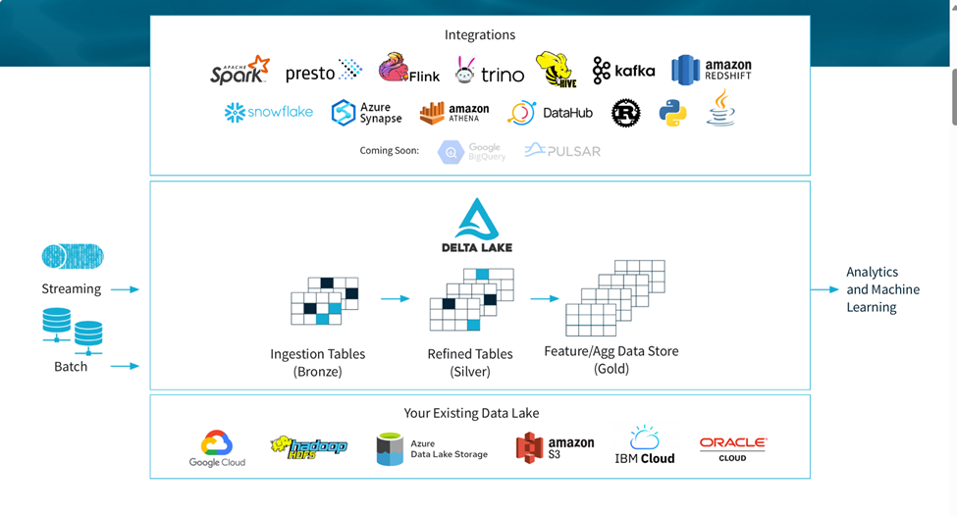

Key Features of Delta Lakehouse
